TRIAL AND IMPROVEMENT METHOD
Pearson Edexcel - Thursday 9 June 2016 - Paper 2 (Calculator) Higher Tier
1.
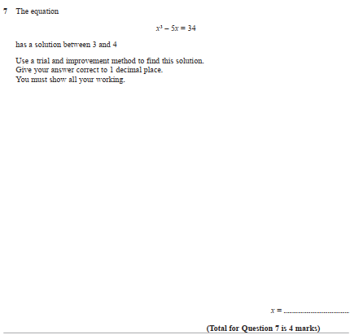

Pearson Edexcel - Monday 8 June 2015 - Paper 2 (Calculator) Higher Tier
2.
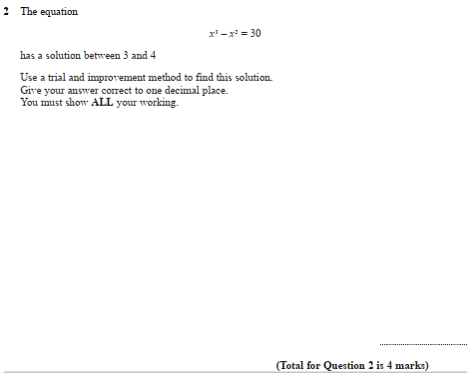
Pearson Edexcel - Friday 7 November 2014 - Paper 2 (Calculator) Higher Tier
3.
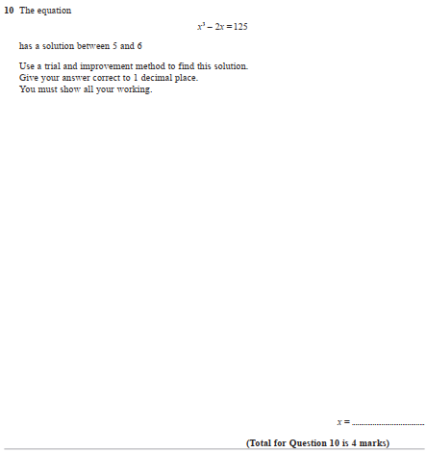
Pearson Edexcel - Friday 14 June 2013 - Paper 2 (Calculator) Higher Tier
4.
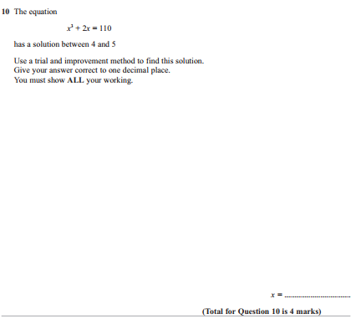

Pearson Edexcel - Monday 4 March 2013 - Paper 2 (Calculator) Higher Tier
5.

Pearson Edexcel - Thursday 8 November 2012 - Paper 2 (Calculator) Higher Tier
6.
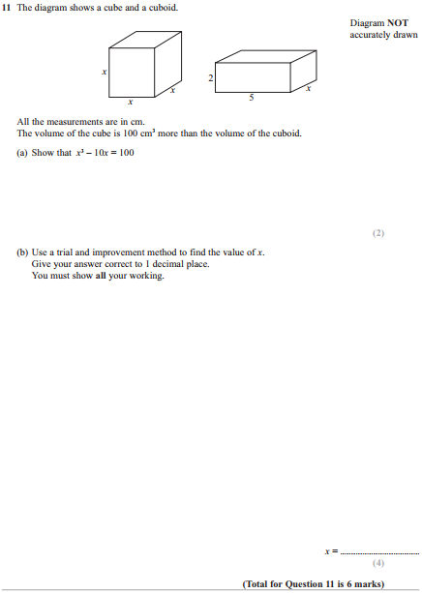

Pearson Edexcel - Wednesday 13 June 2012 - Paper 2 (Calculator) Higher Tier
7.
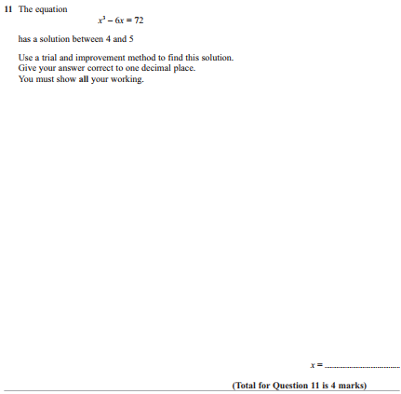

Pearson Edexcel - Monday 5 March 2012 - Paper 4 (Calculator) Higher Tier
8.
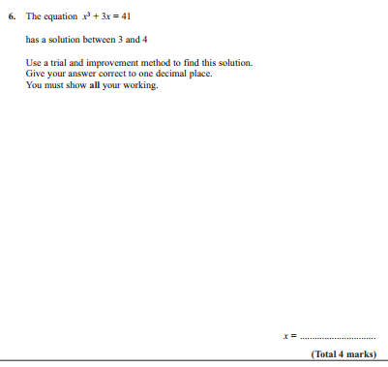
Pearson Edexcel - Friday 10 June 2011 - Paper 4 (Calculator) Higher Tier
9.
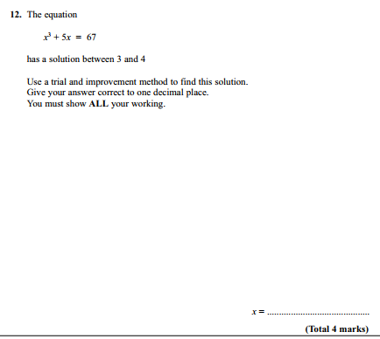

Pearson Edexcel - Friday 11 June 2010 - Paper 4 (Calculator) Higher Tier
10.
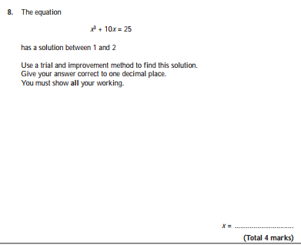
Pearson Edexcel - Tuesday 10 November 2009 - Paper 4 (Calculator) Higher Tier
11.
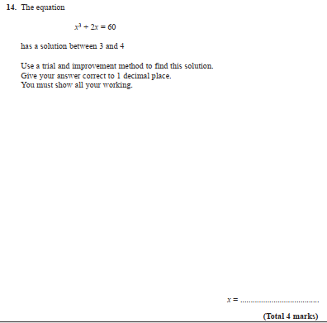
AQA GSCE – Sample Paper 1 (Non - Calculator) Higher Tier
12.
